HILLY FIELDS FOOTBALL CLUB
SEASON 8: 1974-75
FIRST TEAM:
DULWICH LEAGUE:
P W D L F A Pts Pos
Division 1 16 9 2 5 46 35 20 4th
Challenge Cup 1 0 0 1 0 2
Tudor Trophy 2 1 0 1 14 5
Senior Cup 1 0 0 1 1 4
Friendly 1 0 0 1 2 3
TOTAL 21 10 2 9 63 49

Apps Gls Apps Gls
Les Bedden 6 2 Derrick Groom 19 3
Tony Byford 1 1 Malcolm Hill 21 11
Colin Chandler 18 5 Roy Hudson 20 4
Paul Cowdrey 8 2 Bill Irwin 19 0
Paul Ead 17 1 Tony Sanderson 8 0
Alan Folkard 21 7 Bob Shaw 5 0
Martin Formosa 15 0 Jimmy Stamp 2 1
Keith Foster 2 0 Ken Thorn 1 1
Len Franklin 18 4 Bob Whybrow 19 11
Larry Garnham 19 4 John Wise 3 0
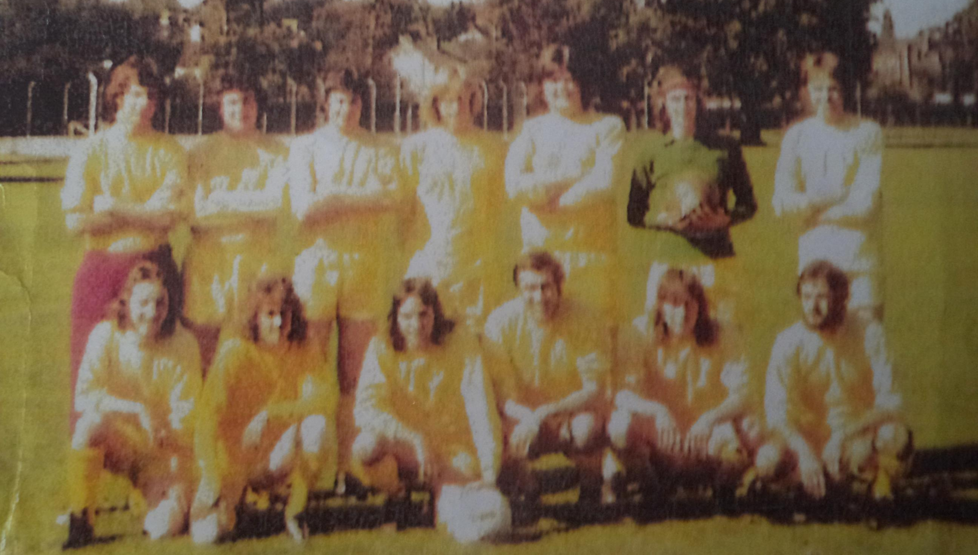
Phil Giles 1 0 OG 6
L-R Back: Keith Foster, Len Franklin, Roy Hudson, Larry Garnham, Colin Chandler, Bob Whybrow, Alan Folkard
L-R Front: Tony Sanderson, Phil Giles, Jimmy Stamp, Derrick Groom, Malcolm Hill, Bill Irwin

